

GUIDANCE FOR DEVELOPING A FLUSHING PROGRAM FOR SCHOOLS

This guidance document was developed to help schools develop a water flushing program to comply with the Montana Department of Public Health and Human Services Lead Reduction in Schools Drinking Water Rule Drinking Water Rule.

What is Flushing?

Flushing is a tool that schools can use to improve their water quality. Flushing involves opening the taps and letting the water run to remove water that has been stagnant in the pipes and fixtures. Stagnant water can accumulate higher concentrations of lead from the surrounding piping and fixtures.

Why Should I Flush?

When a facility is not being used, the water in the plumbing system becomes stagnant. The stagnant water tends to warm up due to the facility’s heating system. The warmer water can be more corrosive to the piping and fixtures causing lead to be leached out of the plumbing. Flushing is a relatively easy and inexpensive maintenance practice to help reduce lead levels in your drinking water.
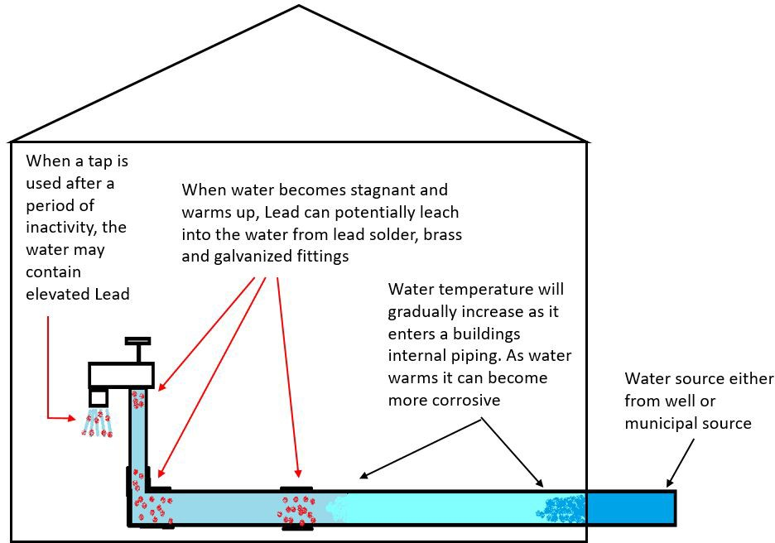

When Should I Flush the Water System?

Flushing must be performed any time the school is inactive (fixture(s) not used for a period of more than 3 days). This includes; but not limited to; holidays, summer vacation or emergency situations. Flushing should also be performed after any type of plumbing or major construction activities. These activities can cause debris on the inside of the pipes to be knocked free into the water and may cause elevated lead concentrations.

Developing a Flushing Plan

The following things should be considered when developing the flushing plan:
- Know where your water is coming into the building either from well or municipal connection.
- Try to determine how your water flows through your building.
- Develop an inventory of all your fixtures and plumbing including type, age and location.
- When developing your inventory don’t forget to include any additional buildings that have a water connection such as shops, garages, or concession stands.
- Fixtures should be flushed individually.
- All fixtures should be flushed including fixtures not intended for human consumption. The goal of flushing is to remove all the water that has been stagnant inside the piping.
- Identify the fixture that is furthest away from your source or entry point.
- Develop a procedure for accountability including who is responsible for flushing and record keeping.
- Use the attached Water Flushing Program template to help develop your program. The template can also be found in the Lead in School section under forms at https://deq.mt.gov/water/programs/dw

Flushing Procedures

Remember that each drinking water outlet should be flushed individually; flushing a toilet will not flush your water fountains. All flushing should be recorded in a log submitted daily to the office, or person, in charge of this program. Flushing should start from the furthest fixture away and working your way back to the source.

  - Locate the fixture furthest away from the source on each wing and floor of the building, open the cold water handle wide, and let the water run until the temperature changes (gets colder) or for at least 10 minutes which is adequate for most buildings. The change in temperature indicates the warmer water in the internal piping of the building has been flushed. The water coming from the source (well or municipal connection) is typically colder. This fixture should not be a drinking water fountain due to the lower flow rate. Another option for flushing duration is to calculate the volume of the plumbing and the flow rate at the fixture and adjust the flushing time accordingly.

  - Prior to opening the tap, remove the aerator from the fixture, if present. This will allow any particulates to be easily flushed out. Inspect the aerator screen. Clean and/or replace if needed and then re-attach after fixture has been flushed.
  - For subsequent fixtures flush by the following techniques:
    - For fixtures with handle(s), open the cold water side and run until temperature changes or at least one minute.
    - For drinking water fountains, run for at least 1 minute.

Tips
- Flushing should be performed as a routine maintenance practice.
- Don’t collect lead samples right after flushing. Allow a minimum of 6 hours after flushing before water samples are collected.
- Identify potential re-uses of the flushed water (e.g. plant watering and cleaning)

Water Flushing Plan & Log

School Name:
School ID#:
Contact Name:

Date of Flushing & Initials for who performed:
ie-8/1/20-GRM

List the fixtures in the order they are to be flushed. Start with Fixture furtherest away from where the water enters the school and than work your way back
Flushing  Order | Fixture # | Type of Fixture | Location of  Fixture | Duration  of Flush | Notes
PAGE of

